BABU BANARASI DAS
UNIVERSITY
(2026-2027)



SCHOOL OF COMPUTER APPLICATIONS
Project File On
NO SQL & DBaas
(BCADSN23202)

Submitted to: Submitted by:
Mr. Harendra Singh Rumana Ali
Date: 30th September BCA (DS & AI)27
Roll No:22
(1250258375)

1. Installation and Configuration of MongoDB
MongoDB is a NoSQL, document-oriented database. It stores data in JSON-like BSON documents instead of rows and columns.
Installation steps on Windows:
A. Download MongoDB Community Server from the official MongoDB website.
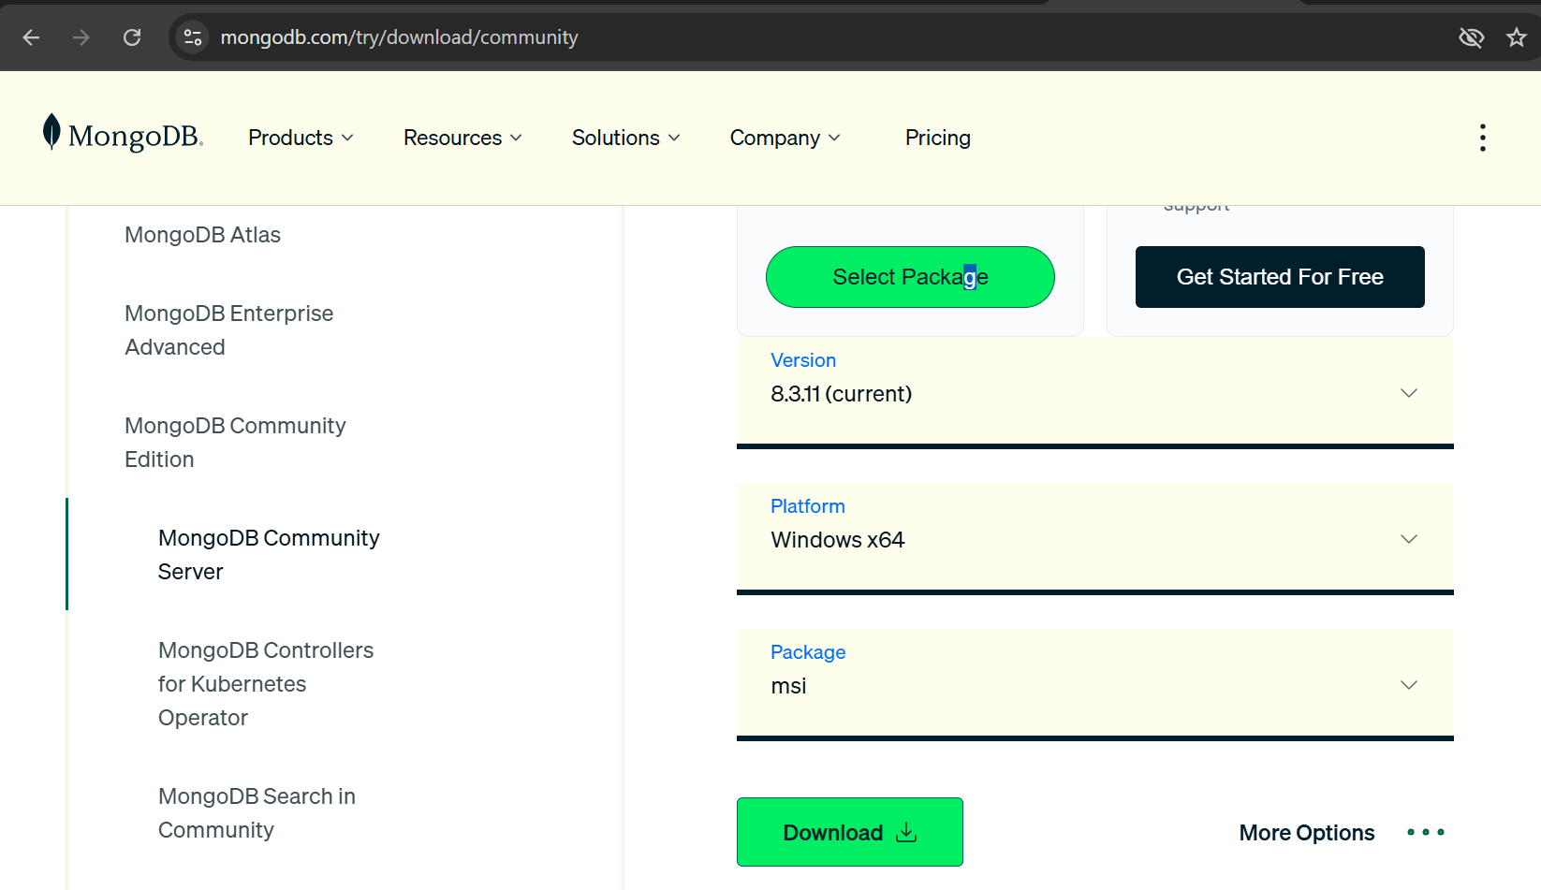

B. Run the installer and select Complete installation.
C. Keep MongoDB Server and MongoDB Compass selected.
D. Complete the installation.
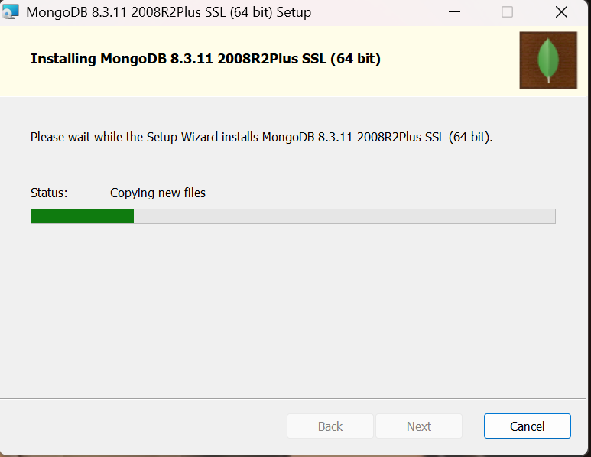
6. Open MongoDB Compass or MongoDB Shell (mongosh) to work with MongoDB.
2. Working with MongoDB Databases
A. Create/select a database:

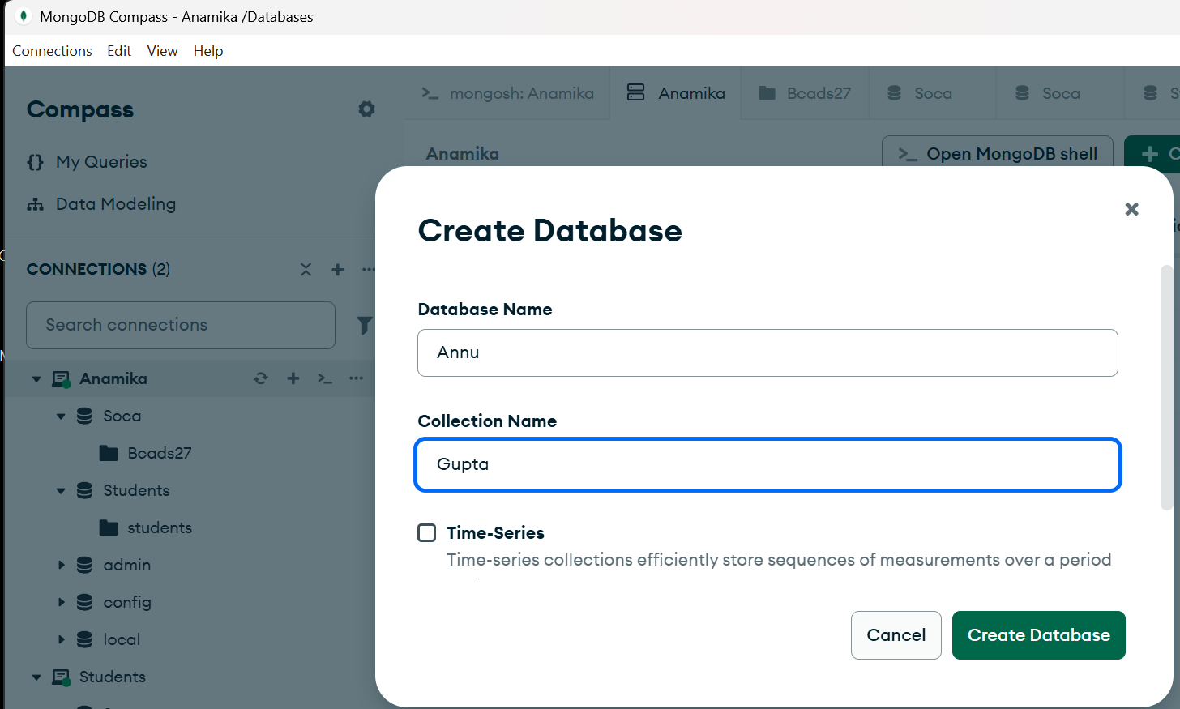

B. Check the current database:

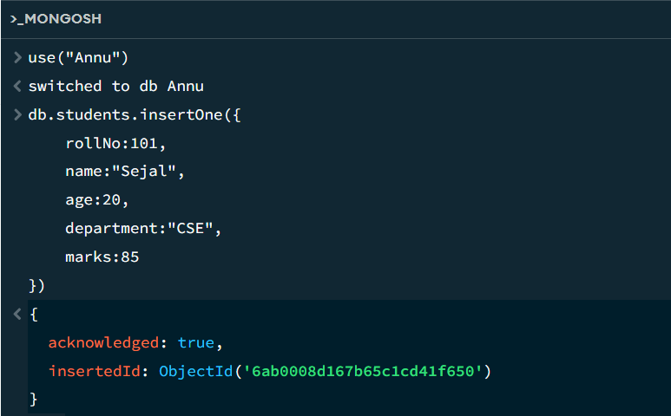

3. Inserting Documents
A. Insert one document:

B. Insert multiple documents:
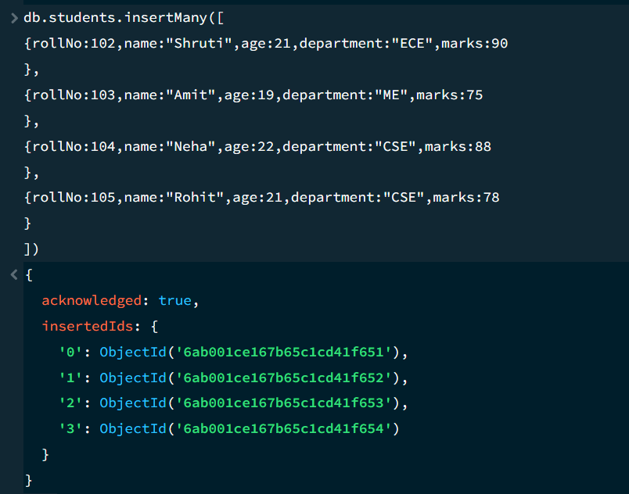

4. MongoDB Query Operators
Comparison operators:
Operator | Meaning
$eq | Equal to
$ne | Not equal to
$gt | Greater than
$gte | Greater than or equal to
$lt | Less than

A. $gt – Marks greater than 80:
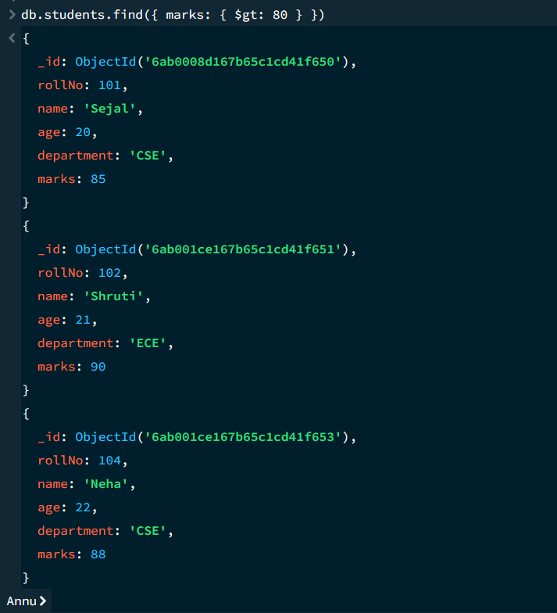

B. $gte – Marks greater than or equal to 85:
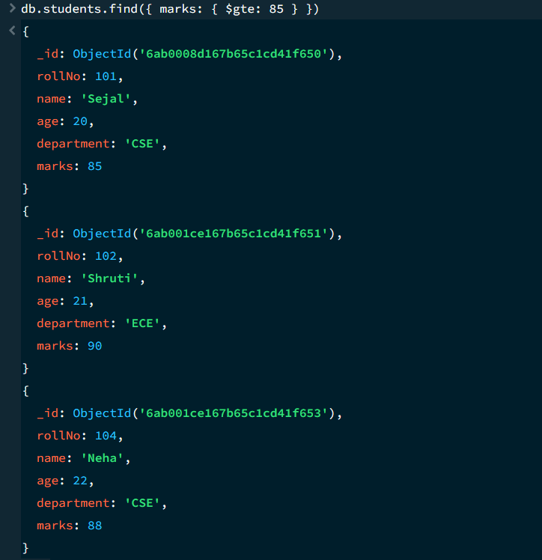

C. $lt – Marks less than 80:
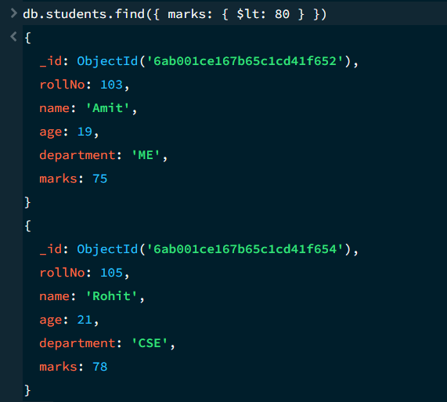
D. $lte – Marks less than or equal to 80:

E. $ne – Marks not equal to 80:
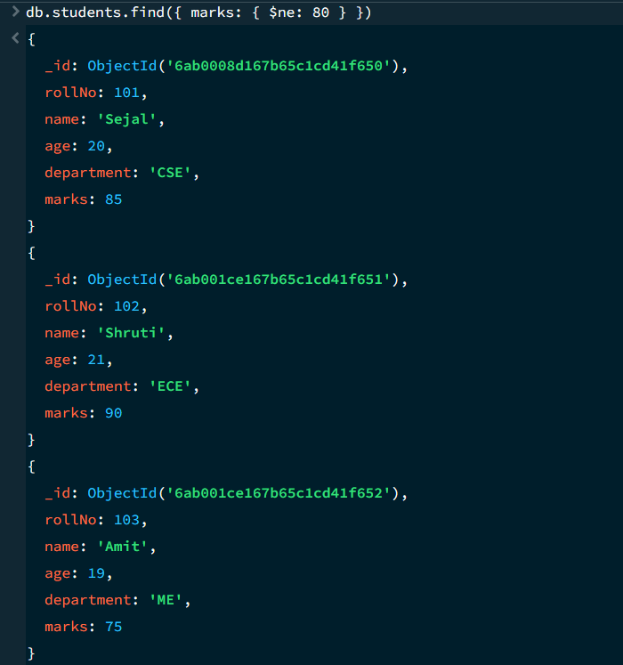

5. Logical Operators
Logical operators include $and, $or, $not and $nor.
A. $and – Both conditions must be true:
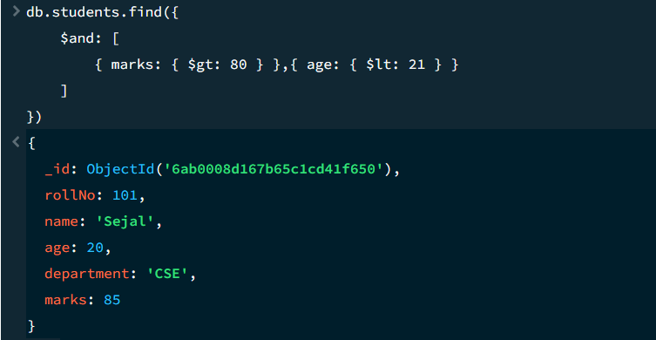

B. $or – At least one condition must be true:
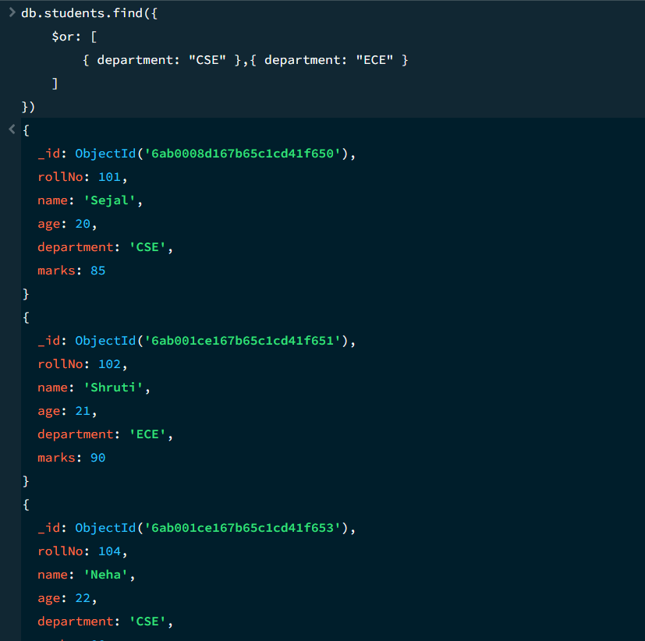
C. Find students whose marks are NOT greater than 80.
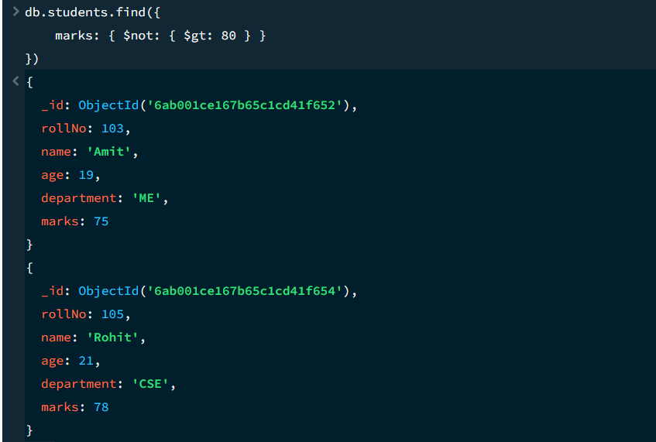
6. Updating Documents
Update one document:

7. Deleting Documents
A. Delete one document:

B. Delete multiple documents:

